FSKM UiTM BRINGS HOME FIRST PLACE PRIZE
By Suzana Zambri and Norkhushaini Awang

FSKM students were crowned champion for the 11th Edition of the F-Secure Cyber Security Competition Malaysia which took place on 29th September 2021.

After an intense grand finals where the team had to compete against nine other finalist teams to ‘Capture the Flag’, FSKM Team H0j3n emerged champions.
The team comprises Muhammad Ali Akbar B. Radzali, Muhammad Idham Bin Idris from Bachelor of Information Systems (Hons.) Intelligent Systems Engineering and Iman Irfan Bin Hisshamudin from Bachelor of Computer Science (Hons.) Data Communication and Networking.
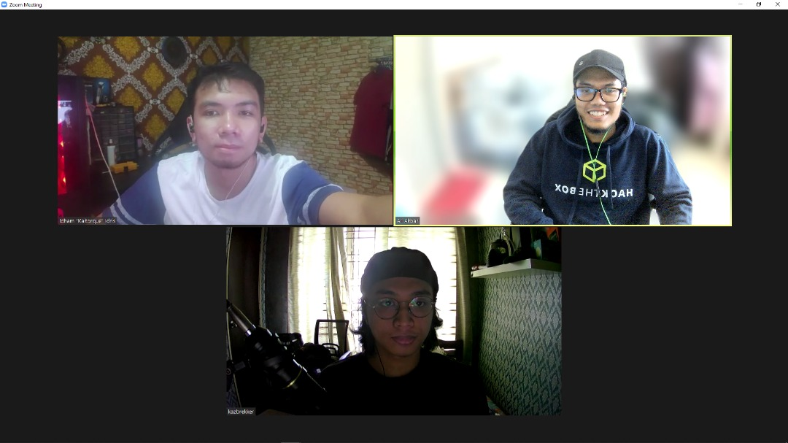

These students were tested with cyber security topics including Reverse Engineering and Analytical Thinking, Cryptography, Malware and Incident Response, Network analysis and Forensics. The competition commenced on 15 September for qualifying round, 22th September 2021 for semi-final round and 29th September grand final has placed UiTM students as champions beating 49 groups from public and private universities.
Team H0j3n took home prizes worth RM2500 which includes Philips 27 Gaming Monitor, Razer Black Widow Mechanical Keyboard (Green Switch) and Logitech G502 Wireless Mouse.
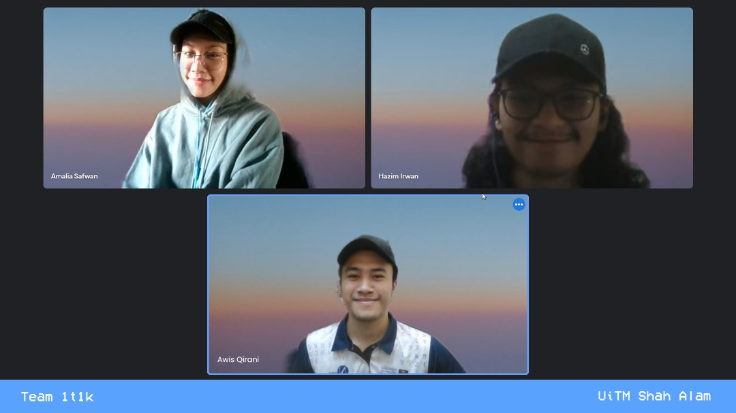

Another FSKM talents that made it to the top 10 finalists is Team 1T1k, represented by Muhammad Hazim Bin Irwan Syah, Muhammad Awis Qirani Bin Zamani from Bachelor of Computer Science (Hons.) Data Communication and Networking and Fakhira Amalia Binti Safwan from Bachelor of Information Systems (Hons.) Intelligent Systems Engineering.
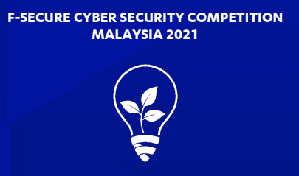

The F-Secure Cyber Security Competition is the brainchild of a long-standing collaboration between F-Secure, the Malaysia Digital Economy Corporation, and various Malaysian public and private universities. This is not the first FSKM winning the competition. In 2018, FSKM bagged first and 5th place.

